**Allergies:** \_\_\_\_\_\_\_\_\_\_\_\_\_\_\_\_\_\_\_\_\_\_\_\_\_\_\_\_\_\_\_\_\_\_\_\_\_\_\_\_\_\_\_\_\_\_\_\_\_\_\_\_\_\_\_\_

**This eczema plan belongs to:** \_\_\_\_\_\_\_\_\_\_\_\_\_\_\_\_\_\_\_\_\_\_ **Date of birth:** \_\_\_\_\_\_\_\_\_\_

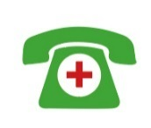

**IMPORTANT!** If skin is crusty, weepy or blisters, speak to a healthcare professional at your surgery the same day

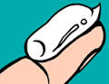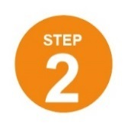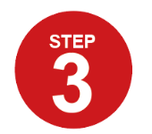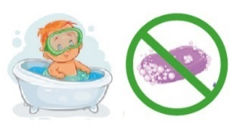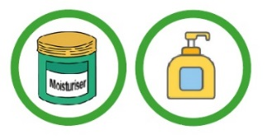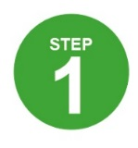

Use all over andoften (usually twice daily)

**Flare/control cream/ointment for my face:**\_\_\_\_\_\_\_\_\_\_\_\_\_\_\_\_\_\_\_\_\_\_

Once/twice daily for \_\_\_\_\_ days

**My non-soap product** (for washing):

\_\_\_\_\_\_\_\_\_\_\_\_\_\_\_\_\_\_\_\_\_\_

**My moisturiser:**

**\_\_\_\_\_\_\_\_\_\_\_\_\_\_\_**

Bathe for a maximum of 10 mins

How to apply your moisturiser: [www.bris.ac.uk/ewap/videos](http://www.bris.ac.uk/ewap/videos)

**No better within 7-14 days**

**Clear skin for 48 hours**

**Red/itchy skin**

**=**

If skin is red or itchy, continue to use my moisturiser plus a flare control cream/ointment applied to the affected areas only

One fingertip treats an area the size of 2 adult hands

Apply at least 15 mins before or after moisturiser using the fingertip unit method [www.bris.ac.uk/ewap/videos](file:///\\ads.bris.ac.uk\filestore\BRMS\Studies\AEr\APACHE\Phase%202\9%20Draft%20WAP\Word%20versions%20of%20WAP\www.bris.ac.uk\ewap\videos)

**Flare/control cream/ointment for my body:** \_\_\_\_\_\_\_\_\_\_\_\_\_\_\_\_\_\_\_\_\_\_

Once/twice daily for \_\_\_\_\_ days

If skin is still not getting better speak to a healthcare professional at my surgery

Moisturise all over EVERY DAY even when my skin is not red/itchy

Avoid soap and bubble bath

**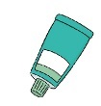**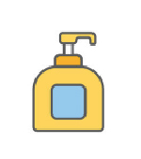

• Corticosteroids come in different strengths: mild (e.g. hydrocortisone 1%), moderate (e.g. eumovate) and potent (e.g. betnovate/elocon).

• Calcinuerin inhibitors (e.g. protopic) are also sometimes recommended.

• Stronger creams and ointments are safe to use if applied in the right way. Follow your plan for which treatment to use where and for how long.

**Recognise a flare:** A ‘flare’ is a worsening of the eczema. Skin may become red, sore, (more) itchy,

crack or bleed.

**Recognise infected eczema:** If skin suddenly worsens, weeps or crusts it could be infected and

your child may need antibiotics – seek urgent advice. Blisters or cold sores need antiviral treatment

– see a doctor the same day.

**Food allergy:** While it is more common for children with eczema to have a food allergy, it is not

usually the cause of eczema.

**Flare control creams or ointments such as corticosteroids or calcineurin inhibitors treat red, itchy skin**

• Moisturisers can also be used to wash with

but take care, they can make the bath/shower

slippy

• PAT your skin dry after bathing and apply your moisturiser straight afterwards.

• Applying moisturisers can be messy, but they wash off.

• **FIRE HAZARD** – Keep greasy ointments away from flames.

* • It’s ok to try different moisturisers, talk to your

GP/nurse if you don’t like one you have been

given.

• Expect to use large amounts – up to a large pump/tub (500ml/g) a week.

• If your moisturiser comes in a tub, use a spoon to scoop the moisturiser out. Getting it out with your hands can contaminate the pot and lead to skin infections.

**Moisturising the skin keeps moisture in and protects against outside irritants. Find a moisturiser that suits you and your child and use it every day**

*Try to break the “itch-scratch”*

*cycle by tapping or blowing on the itch area; using a cold pack; or wearing cotton gloves at night.*

*There are different types of*

*moisturisers - if you don’t like yours, ask your GP for*

*a different one.*

**Things that can make the skin worse**

• Soaps and bubble baths

• Perfumed products

• Detergents

• Wool clothing

• Extremes of temperature (e.g. hot bath water)

• Sand, soil, modelling clay, paints

• Stress

Links to check out

<http://eczema.org/>

<http://www.nottinghameczema.org.uk/>

<http://www.nhs.uk/conditions/Eczema-(atopic)>

<http://eczemaoutreachscotland.org.uk/>

**Top Tips**

• Moisturise every day, even when the skin is clear

• Apply moisturiser using downward strokes – do not rub in

• Do an extra rinse when washing clothes

• Wear soft, comfortable, loose clothing

• Keep fingernails short to prevent damage to skin

• Remember to re-order your creams

**Eczema is a long-term condition that comes in cycles – getting worse and better. Good skin care with two treatments (moisturiser and flare cream/ointment) used well can control most children’s eczema.**

**[Eczema essentials]**

|  |  |
| --- | --- |
|  | **Record of your child’s treatment preferences** |

|  |  |  |  |  |  |
| --- | --- | --- | --- | --- | --- |
| My treatment | When used | Rate your treatment | | | Notes |
| *e.g. Hydromol ointment* | *January-March 2017* |  |  |  | *Effective but greasy when put on skin* |
|  |  |  |  |  |  |
|  |  |  |  |  |  |
|  |  |  |  |  |  |
|  |  |  |  |  |  |
|  |  |  |  |  |  |
|  |  |  |  |  |  |
|  |  |  |  |  |  |
|  |  |  |  |  |  |

|  |
| --- |
| Other treatments tried (prescribed or non-prescribed): |

|  |  |
| --- | --- |
| C:\Users\kp9225\AppData\Local\Microsoft\Windows\Temporary Internet Files\Content.Word\Funded_by_NHS.JPG | **© University of Bristol 2017** (Fingertip unit image reproduced with permission from Australasian Society of Clinical Immunology and Allergy (ASCIA) [www.allergy.org.au](http://www.allergy.org.au))  WAP freely available for use by children, parents and clinicians. Please obtain permission before use in research or modifying. For full licence and further information see www.bristol.ac.uk/ewap |